Implement Virtual Networking

Lab Overview
This lab introduces Azure Virtual Networking fundamentals. You create virtual networks and subnets, secure traffic using NSG and ASG, and configure Azure DNS (public and private).
Estimated Time: 50 minutes
Region Used: East US
Resource Group: az104-rg4

Lab Scenario (Simple Explanation)
Your organization is expanding globally and needs a scalable, secure network design.
You will:
- Create two virtual networks with non-overlapping IP ranges
- Use subnets to separate workloads
- Secure traffic using NSG and ASG
- Configure DNS name resolution for public and private access

Architecture diagram
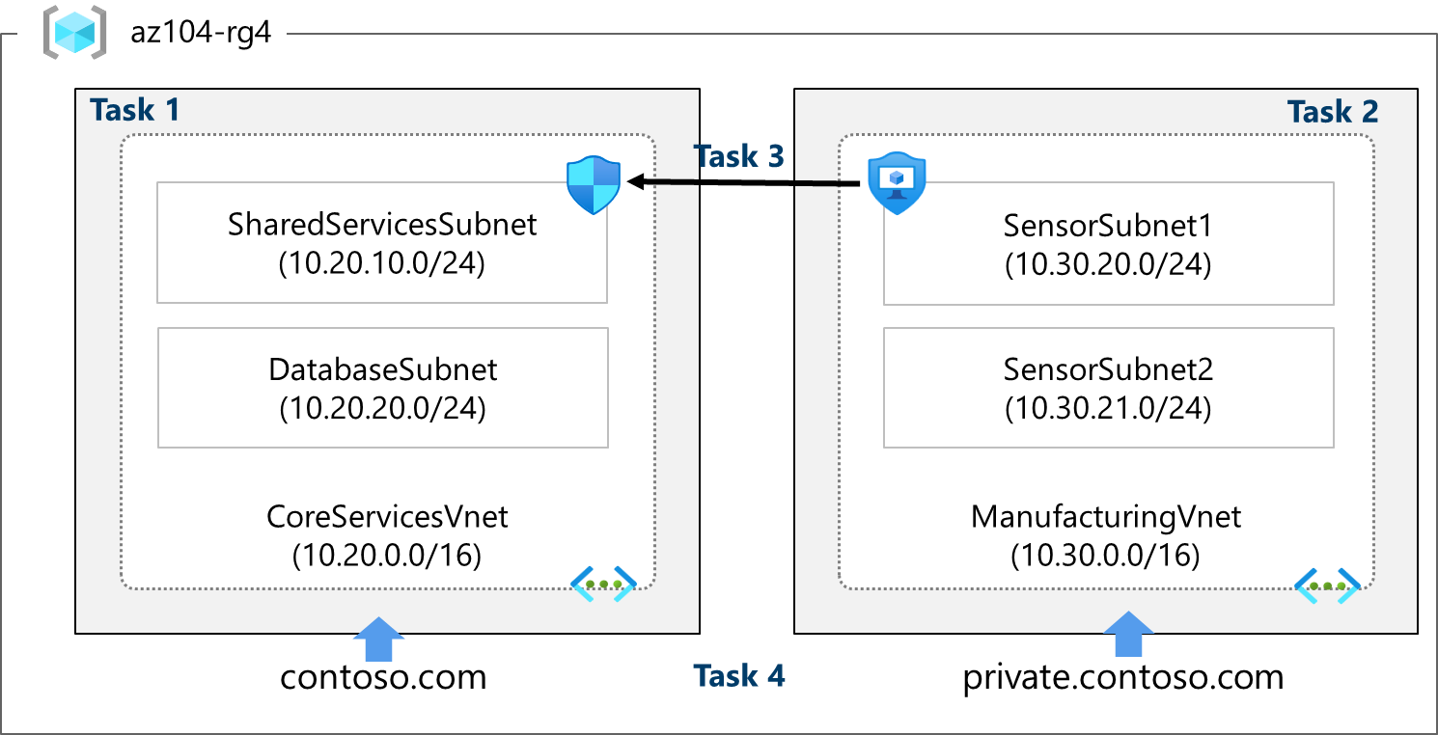

Task 1 – Create Virtual Network and Subnets (Portal)

Create CoreServicesVnet
Setting | Value
Name | CoreServicesVnet
Address space | 10.20.0.0/16
Region | East US
Resource Group | az104-rg4

Create Subnets
Subnet Name | Address Range
SharedServicesSubnet | 10.20.10.0/24
DatabaseSubnet | 10.20.20.0/24
Important Notes
- Every VNet must have at least one subnet
- Azure reserves 5 IP addresses per subnet
- Avoid overlapping IP ranges
After creation:
- Verify Address space
- Verify Subnets
- Export the ARM template (used in Task 2)

Task 2 – Create Virtual Network Using ARM Template

Create ManufacturingVnet (Using Template)
Component | Value
VNet name | ManufacturingVnet
Address space | 10.30.0.0/16

Create Subnets
Subnet | Address
SensorSubnet1 | 10.30.20.0/24
SensorSubnet2 | 10.30.21.0/24
Why use templates?
- Faster deployment
- Consistent configuration
- Reduces manual errors
- Reusable across environments

Task 3 – Secure Traffic Using ASG and NSG

Application Security Group (ASG)
Setting | Value
Name | asg-web
Purpose | Group web servers
ASG Key Point
- ASG groups VMs by role, not IP
- Makes NSG rules easier to manage

Network Security Group (NSG)
Setting | Value
Name | myNSGSecure
Associated subnet | SharedServicesSubnet

NSG Inbound Rule (Allow Web Traffic)
Setting | Value
Source | ASG (asg-web)
Ports | 80, 443
Protocol | TCP
Action | Allow
Priority | 100

NSG Outbound Rule (Deny Internet Access)
Setting | Value
Destination | Internet
Action | Deny
Priority | 4096
Result
- Web traffic allowed from ASG
- Internet access blocked from subnet

Task 4 – Configure Azure DNS

Public DNS Zone
Setting | Value
Zone name | contoso.com
Record type | A
Record name | www
IP Address | 10.1.1.4
Verification
nslookup www.contoso.com <Azure-name-server>

Private DNS Zone
Setting | Value
Zone name | private.contoso.com
Linked VNet | ManufacturingVnet

Private Record
Name | IP
sensorvm | 10.1.1.4
Key Point
- Private DNS zones work only inside linked VNets
- Not accessible from the internet

